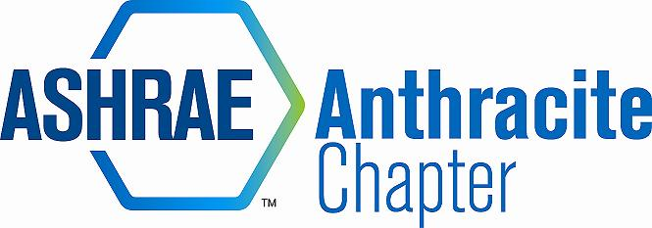
AGENDA – October Board Meeting
October 21, 2014
ARCARO AND GENELL, OLD FORGE, PA
- Call to Order – call to order MA (5:06)
  - Roll Call
  - Motion to approval of September Meeting Minute, Summer Planning (as amended), and September Meetings made by MA, 2nd RK
- 2013-14 OFFICERS & CHAIRS
 | Present | Absent
Matt Archey, PE(MA)…….President | X
Rich Karns(RK)………...President-Elect | X
Patrick Salmon(PS)……Vice-President |  | X
Alyssa Procida(AP)….. Treasurer | X
Jon Keller(JK)…………….Secretary & Membership Promotion | X
Tracey Jumper(TJ)…….Board of Governors & Student Activities | X (late)
Dan Mello(DM)………...Board of Governors | X
John Durdnan,PE(JD)...Board of Governors | X
Dave Onufer……………..Chapter Technology Transfer Chair | X
Maxwell Tamasy (MT).Research Promotion |  | X
Will Seiberling(WS)….…Young Engineers in ASHRAE (YEA) | X
Walt Janus(WJ)………....Historian & Newsletter Editor | X
Karl Grasso(KG)………….Website Homepage Editor | X
Gary Debes(GD)………….Research Promotion Co-Chair | X
A.J. Speicher,PE(AJ)……..Grassroots Government Activities Chair |  | X

- Committee Reports (email updates going forward) (5:03-5:25)
  - Membership
    - Delinquent/prospective members
    - JK posted reports to DropBox, everyone is asked to look on cancelled member list and reach out to anyone personally on the list. RK to reach out to Mike Troy
  - CTTC
    - Remaining Programs (use cash positive venues)
    - DO & JD working on filling the remaining meeting slots. Next month SBC brewery tour (Student Night) and dinner to be booked at Coopers in Pittston
    - January meeting w/ SMACNA, February meeting is engineers week – trying to plan an interesting topic March unknown (trying to plan Tom Phoenix visit), April & May trying to schedule joint meeting with AIA
  - Treasurer
    - Credit Card Reader Decision – GD spoke about the pros/cons of Square vs Paypal. Both 2.75% cost per transaction. Prefers Square.
    - JD made the motion to open & activate a Square account, 2nd DM – motion carries
    - GD set up chapter account – Chapter President, Secretary, and Treasurer to have access to PW and login information. PW to change annually.
    - Need for additional fundraiser to support scholarships
      - Put off till next meeting – TJ to follow up with Wilkes
    - Chapter Balance: $44,153.78
  - Research Promotion
    - Full Circle – GD current $300 total donation as of today, Chapter Officers and RP to donate $100 by Nov 15th deadline to achieve full circle. BOG members to participate if possible.
  - Student Activities – K-12 initiatives
    - TJ to follow up next meeting.
  - YEA
    - November is YEA social – SBC brewery tour – 18 to tour, 21 to taste!
    - 5k opportunity???
      - WS to look into the organization of a 5k to support student chapter donations, the money raised can be used 50% Wilkes Student Chapter, 50% Scholarships = win/win
      - Estimates: 100 registered = $1,500 net profit,
  - GGAC
  - Historian
- PAOE (5:25-5:30)
  - MA reminds all to update PAOE totals every month

- Old Business (5:30-5:32)
  - Historical items for storage unit

- New Business (5:32-5:40)
  - Open Discussion

- Review of Action Items (Secretary) (5:40-5:45)
  - PAOE reminder
  - RP full circle before next month
  - TJ to look into Wilkes Scholarships
- Adjournment Motion to adjurn JD, 2nd KG (5:50)

