[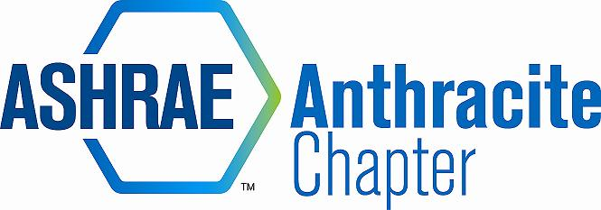](http://www.google.com/url?sa=i&source=images&cd=&cad=rja&docid=yeF2_ZdoF2U-EM&tbnid=OwN6kaV4JF7BtM:&ved=0CAgQjRwwAA&url=http://anthracite.ashraechapters.org/&ei=ltPuUZuhFY-89gS1goGwBg&psig=AFQjCNFwvNW1_vSmgsndEE-S5GkquQ93Zw&ust=1374692630468185)

AGENDA – September Board Meeting  
September 16, 2014  
COOPER’S SEAFOOD WATERFRONT, PITTSTON, PA

* Call to Order by MA (5:06)
  + Roll Call
  + Approval of Previous Meeting Minutes not completed

|  |  |  |
| --- | --- | --- |
| 2013-14 OFFICERS & CHAIRS | | |
|  | Present | Absent |
| Matt Archey, PE(MA)…….President | X |  |
| Rich Karns(RK)………...President-Elect | X |  |
| Patrick Salmon(PS)……Vice-President |  | X |
| Alyssa Procida(AP)….. Treasurer | X |  |
| Jon Keller(JK)…………….Secretary & Membership Promotion | X |  |
| Tracey Jumper(TJ)…….Board of Governors & Student Activities |  | X |
| Dan Mello(DM)………...Board of Governors | X |  |
| John Durdnan,PE(JD)...Board of Governors |  | X |
| Dave Onufer……………..Chapter Technology Transfer Chair | X |  |
| Maxwell Tamasy (MT).Research Promotion |  | X |
| Will Seiberling(WS)….…Young Engineers in ASHRAE (YEA) |  | X |
| Walt Janus(WJ)………....Historian & Newsletter Editor | X |  |
| Karl Grasso(KG)………….Website Homepage Editor | X |  |
| Gary Debes(GD)………….Research Promotion Co-Chair | X |  |
| A.J. Speicher,PE(AJ)……..Grassroots Government Activities Chair |  | X |

* Committee Reports (email updates going forward)
  + Membership
    - Delinquent/prospective members
  + CTTC
    - Remaining Programs (use cash positive venues)
    - D.O. – programs are scheduled through November, working on securing a location for November
    - AP will get 2-3 folding tables donated from Trane to keep in the storage unit. Tables can be used for any events we have in the future.
  + Treasurer
    - Budget Shortfall anticipated
      * AP presented her calculated budget shortfall for the year (based on 2013-14 expenses and revenues). We anticipate approximately $3,000-4,000 deficit if nothing is changed
      * Action item: All to brainstorm revenue generating ideas and expense reducing ideas
      * GD indicated we can change our chapter dues amount. Motion by DM, 2nd by AP to increase chapter dues from $20 to $30 October 1, 2014. Motion carries 4-0-0 CNV. MA to pursue with ASHRAE society.
    - Credit Card Reader Discussion
      * AP discussion of tablet vs CC reader
      * Additional $1 charged per
    - Need for additional fundraiser to support scholarships
    - Chapter balance as of 9/16/14: $43,782.13
  + Research Promotion
    - Full Circle – All officers & RP chair to lead by example by November 15th
    - October’s meeting is RP night
    - Donor Call Campaign (endowment and general RP fund)
      * GD suggests we have a donor calling campaign
  + Student Activities – K-12 initiatives
    - To plan activities with Wilkes and Wyoming Seminary
  + YEA – November is YEA social
  + ~~GGAC~~
  + ~~Historian~~
* PAOE
  + Update your totals every month!
  + PAOE points broken out on DropBox
* ~~Old Business~~ 
  + ~~N/A~~
* New Business
  + Open Discussion
* Review of Action Items
* Adjournment – Motion to ajdurn: DM, 2nd KG (5:56)