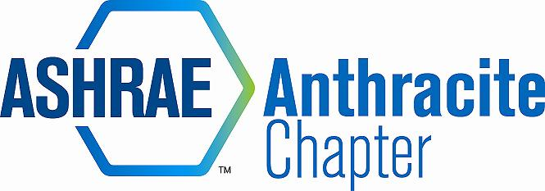
AGENDA – APRIL BOARD MEETING
APRIL 15, 2014
The Hilton, Scranton, PA
- Call to Order (5:06)
  - Roll Call
  - Approval of Previous Meeting Minutes -
2013-14 OFFICERS & CHAIRS
 | Present | Absent
Matt Archey(MA)…….President | X
Rich Karns(RK)………...President-Elect | x
Patrick Salmon(PS)……Vice-President | X
Alyssa Procida(AP)….. Treasurer | X
Jon Keller(JK)…………….Secretary & Membership Promotion | X
Tracey Jumper(TJ)…….Board of Governors & Student Activities | x
Dan Mello(DM)………...Board of Governors | X
Tom Swartwood(TS)...Board of Governors |  | X
John Durdan(JD)……..…Chapter Technology Transfer Chair | X
Ron Sibulsky(RS)…………Research Promotion | X
Will Seiberling(WS)….…Young Engineers in ASHRAE (YEA) |  | x
Walt Janus(WJ)………....Historian & Newsletter Editor |  | x
Karl Grasso(KG)………….Website Homepage Editor | X
Gary Debes(GD)………….RVC of Membership Promotion |  | x
Phil Latinski…………………Chapter Member, Past President |  | x
Dave Onufer……………….Potential Member |  | x

- Nominating Committee Discussion (5:06)
  - Finalize nominees for open positions – need a president elect spot, PS is VP
    - DM suggests we maintain another year with current officers, officers agreed
    - Still need treasurer for next year, nominate Dave Onufer for treasurer and open floor call at tonight’s meeting
    - We need to hold nominations this month – will be held electronically

  - Ballot will be by Survey Monkey – MSA to email to Chapter this week
- Committee Reports (5:06)
  - CTTC
    - Stepping down from CTTC
    - Remaining Programs – next month undetermined
    - Webinar Update (MA)- This Thursday at Wilkes University, 1:00 pm – we would like to provide refreshments
  - Membership
    - Training reimbursement for MP promotion
  - Treasurer
    - CMAVTS Scholarship – Awards Ceremony is May 22nd at 9am. Attendee(s)?
      - Scholarships – $300 per scholarship for two students. Chapter needs two volunteers to hand out scholarship at the awards ceremony.
    - As of April 15th, 2014 – Chapter Balance $45,752.12
    - JD secured tonight’s meeting on his CC.
    - Scholarships for Wilkes – recipients will be determined by professor.
    - We need to conduct an audit – a committee of three members need to be formed.
    - Audit Committee Selection – DM, AP
  - Student Activities
    - K-12 volunteer opportunity – tonight is student night
    - Few student members graduating – TJ ordered a banner for student chapter- JD motion to purchase banner $115 for student chapter, 2nd by KG
    - Student chapter held student elections, Sam (chapter president) to speak tonight
  - Research Promotion
    - Car Show – Aircon $100 research donation
    - 2014 ASHRAE Car Show report passed out
    - RS to purchase shirts for show to sell – Cobalt blue w/ powder blue letter
    - PS, DM, AP, RK to volunteer, AP to judge cars
    - Additional folding table could be used.
    - Snow has melted! BUT, huge potholes in lot
    - RK to sponsor a 1st place trophy
    - Golf Tournament – WS and JK held first meeting, need to revise flyer and sent to WJ
  - YEA – WS absent
  - Historian – WJ absent

- Old Business (5:50)
  - PAOE – Deadline is May 30. Let Matt know if you need help!
  - Storage Locker – still need items

- New Business (5:50)
  - Open Discussion – RK – Jim Coleman would like to hand out a “help wanted” add for Coleman Sales

- Adjournment - Motion to adjourn MA, 2nd RK (5:54)

