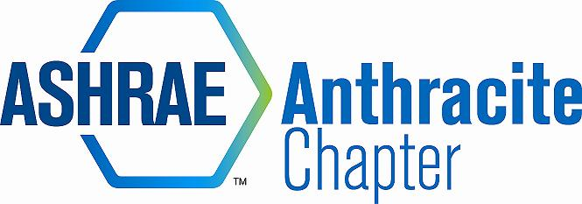
AGENDA – NOVEMBER BOARD MEETING
January 14, 2014
Cooper’s Seafood House, Scranton, PA
- Call to Order - MA Call to Order, 2nd RK (5:05)
  - Roll Call
- 2013-14 OFFICERS & CHAIRS
 | Present | Absent
Matt Archey(MA)…….President | X
Rich Karns(RK)………...President-Elect | X
Patrick Salmon(PS)……Vice-President |  | X
Alyssa Procida(AP)….. Treasurer | X
Jon Keller(JK)…………….Secretary & Membership Promotion | X
Tracey Jumper(TJ)…….Board of Governors & Student Activities |  | X
Dan Mello(DM)………...Board of Governors | X
Tom Swartwood(TS)...Board of Governors |  | X
John Durdan(JD)……..…Chapter Technology Transfer Chair | X
Ron Sibulsky(RS)…………Research Promotion | X
Will Seiberling(WS)….…Young Engineers in ASHRAE (YEA) | X
Walt Janus(WJ)………....Historian & Newsletter Editor | X
Karl Grasso(KG)………….Website Homepage Editor | X
Gary Debes(GD)………….RVC of Membership Promotion |  | X
Eric Tuner…………………..Committee member of CTTC |  | X

  - Approval of Previous Meeting Minutes
    - Motion to Approve: JD, RK 2nd ***Eric Turner, Correction***

- Nominating Committee Discussion (5:07-5:19)
  - 1 Member of BOG (Not allowed to be chair)
  - 4 Members in good standing
  - Need a total of 5 members
  - DM volunteered for BOG position, Kerry Freeman, Walt Janus, John Durdan, Ron Sibulsky, Dan Mello
  - The purpose of the nominating committee is to seek out people within the chapter to assess and nominate chapter members to volunteer
  - Motion to reduce the amount of the nominating committee to 3 members in good stacking: JD, 2nd RM

- Committee Reports (5:20-5:22)
  - CTTC
    - February program (Engineer’s week) – Joint meeting with PSPE
    - Working with Mr. McGraw to host meeting at Berwick Power Plant, and meeting at Mel-Roe’s Family Restaurant In Berwick after the tour
    - Holiday get-together was a flop, distance, promotion, and weather was the demise
  - Membership
    - Delinquent members paid in full
  - Treasurer
    - AP, new report on DropBox
    - Reserved bus for AHR Expo, paid in full
    - YEA event at Chakos
    - Reimbursement to JK for student member dues
    - 3 Sponsor checks for bus trip: Bitzer, Strunk Albert, HC Nye, HVAC Dist, Troy, JF O’hora
    - AP to order check
    - Balance: $44,429.66, *Does not include sponsorship deposits
  - Student Activities
    - TJ Absent, 8 students to attend tonight’s meeting
    - 12 Members in Wilkes University Student Chapter
  - Research Promotion
    - RS, still working on car show site
    - Still looking for car show sponsors
    - RP donation running behind compared to next year, deadline for donation: June 15th
    - Donation from NRG controls $100.00
  - YEA
    - WS, bowling was a success
    - WS to budget and arrange next event during spring semester
  - Historian
  - GGAC

- Winter Conference (5:30-5:35)
  - Attendance Update
  - Final approval of Chapter expenses for trip
    - Bus is not currently full: (31) signed up, (55) capacity
    - 8:00 am – Sears – Wyoming Valley Mall, Leave NYC 5:00 pm (with stop)

- Old Business (5:35-5:38)
  - PAOE – focus on your goals and areas!!!
    - In DropBox, make sure to stay on task
  - Storage Locker – WJ still need items

- New Business (5:38-5:45)
  - Open Discussion
  - Golf tournament: WS to help with committee, new signs to be made, AP to help
  - Car show

- Adjournment (5:45)
  - Motion to adjourn: JD, 2nd, DM

