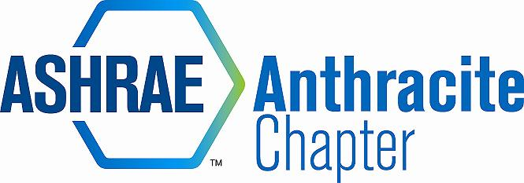
DRAFT MINUTES – May 17, 2016 Board Meeting
Holiday Inn Wilkes Barre – East Mountain
- Call to Order (5:03)
  - Roll Call – Walt Janus (WJ), Eric Turner (ET), Matt Archey (MA), Gary Booth (GB), Dan Mello (DM), AJ Speicher (AS), Rich Karns (RK), Jon Keller (JK), Alyssa Procida (AP), Matt Grasso (MG)
Guest – Bill Bahnfleth
  - Approval of Previous Meeting Minutes
    - Motion – MA
    - 2nd – DM
    - Approved - Unanimous

- Committee Reports .
  - Treasurer
    - Treasurer’s Report
      - JK Provided report for past 3 months
      - Radisson Scranton billed us 4 times for March meeting – JK to follow up and resolve.
  - Research Promotion – CHECKS TO ASHRAE ATLANTA
    - JK presented concern with Kerry Freeman submitting RP donation that was deposited into our general fund and requires submission to Society for RP recognition. JK to address. RK will request from chapter that all RP donations be submitted online or sent directly to Atlanta.
  - Student Activities
    - Tracey Jumper not present – no Student Activities report
- GGAC
    - AS had meeting scheduled with Matt Cartwright’s office, but that meeting was canceled by Congressman. No word on new meeting date.
    - Proclamations for 2015-16 year exceeded that of previous.
- Membership Promotion
- DM upgraded to Life Member – Congrats to Dan Mello!
- MA reminded group that many chapter members become delinquent on July 1st, which impacts PAOE point totals. GB will run report for delinquent members and filter for July 1 date and begin contacting those whose membership will lapse at that time.
- YEA
- Walt Stout not present – no YEA report
- CTTC
- All programs for 2015-16 are complete. MA has received offers for 6 programs in 2016-17 and will begin scheduling
- Bill Bahnfleth in attendance as DL – originally non-allocated, but became allocated visit.
- Webcast Report
- Successful event at Ruth’s Chris Wilkes-Barre – 32 people in attendance, and feedback was very positive. The venue was a big hit.

- PAOE
  - Update totals online and email updates to RVCs – DEADLINE FOR ENTRY IS THE 15TH
    - RK reminded all to update totals online prior to end of Society Year. All committee chairs will update PAOE totals by June 15th.

- Old Business
- Golf Outing
- JK scheduled committee meeting for Thursday, May 19 to review and assign roles
- Registrations are strong within first couple weeks of being open.
- Walt Stout will contact all prior sponsors for repeat contributions.
- Scholarships – Award on May 20
- RK and AP will attend the Columbia Montour AVTS awards ceremony and present two scholarships
- New Business
  - Coal Tokens
    - MG stopped at Superior Trophy and obtained 6 more coal tokens.
    - Gerry Welby missed trophy delivery and was unsure of price for billing. MA advised that we owe for 6 tokens purchased at beginning of year and the current 6 = 12 total with payment outstanding.
    - JK to check financial records for cost to reimburse Patrick Salmon for last year’s purchase, and pay Superior Trophy
    - Decision was made to obtain 16 coal tokens, pay for all of them, and determine how many pieces of our anthracite coal Gerry has in his possession.
  - Open Discussion
    - Bill Bahnfleth advised that the GGAC group is being emphasized and PAOE for this group will expand for 2016-17 year.
    - Bill asked that Chapter members give feedback to Society in Atlanta for continuous improvement of support and Society operations.
- Adjournment (5:39)
  - Motion – GB
  - 2nd – ET
  - Approved - Unanimous

