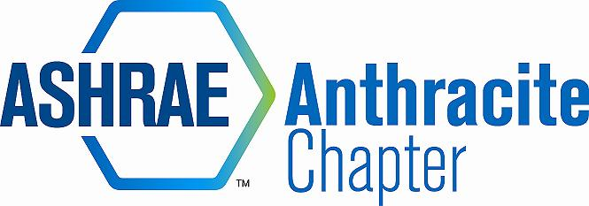
DRAFT Meeting Minutes – April 19, 2016 Board Meeting
Rodano’s, Wilkes-Barre PA
- Call to Order (5:15)
  - Roll Call
      - Tracey Jumper, Dan Mello, A.J. Speicher, Eric Turner, Jon Keller, Walt Stout, Walt Janus, Alyssa Procida, Rich Karns
  - Approval of Previous Meeting Minutes
      - Secretary not present – no minutes presented

- Committee Reports
  - Treasurer
    - Treasurer’s Report
      - Current Balance is not present – will be emailed.
    - Small Game of Chance License:
      - First submission denied because N990 was used in place of W9.
      - W9 has been requested from ASHRAE
      - Being resubmitted with W9.
    - Jon Keller to buy a Chip Card reader for the square app.
  - Research Promotion
- No news to present
  - Student Activities
- K-12 Initiative/Wilkes University Chapter Restart (New Members)
      - Also discussed possibility of joining forces with the Wilkes University PSPE chapter so both groups can help each other grow.
      - Walt Stout to look into how current Wilkes ASHRAE meetings are being conducted.
- GGAC
    - No news to present
- Membership Promotion
    - No news to present
- YEA
    - YEA Wilkes Bowling event was a success. Turnout was 21 people: 14 students and 7 young professionals.
- CTTC
  - No news to present

- PAOE
  - Update totals online and email updates to RVCs
- Old Business
  - Golf Outing
    - Jon to organize meeting with Golf Outing Team
    - New flyers to be made.
    - Costs could be restructured.
    - Sponsorships costs to be increased.
  - Scholarship award ceremony to be presented on May 20. (2) Scholarships to be awarded for $300, for Drafting and HVAC. Alyssa and Rich to attend.
  - Help wanted ads – 1 has been placed
  - Coal Tokens – being taken care of by Matt Archey (not present)
- New Business
  - ASHRAE Webcast – April 21, 2016 (Making Net Zero Net Positive)
    - Event to be held at Ruth Chris at Casino.
  - Past Presidents Pins
    - Jon Keller ordering past presidents pins
    - A.J. Speicher has never received his past presidents pin
  - Election Results
    - Election results to be presented at end of meeting.
  - Open Discussion
- Adjournment (5:55)

