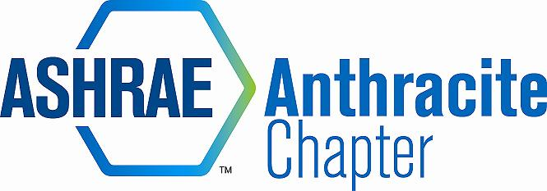
DRAFT Meeting Minutes – February 16, 2016 Board Meeting
Radisson Scranton
- Call to Order (5:06)
  - Roll Call
      - Karl Grasso, Jon Keller, Walt Stout, Walt Janus, Gary Booth, Alyssa Procida, Matt Archey, Rich Karns
  - Approval of Previous Meeting Minutes
      - Secretary not present – no minutes presented

- Committee Reports
  - Treasurer
    - Treasurer’s Report
      - Current Balance is $46,982.33
      - Jon Keller keeping profit/loss statement for each meeting to help with venue evaluations. January meeting had a net profit of $18.62
  - Research Promotion
- Donor Recognition Certificates
      - RP Chair not present – no RP report or discussion of Donor Certificates
  - Student Activities
- K-12 Initiative/Wilkes University Chapter Restart (New Members)
      - SA Chair not present and has been unresponsive. Concern with lack of support for Wilkes University was discussed. Rich Karns to contact SA chair directly
      - Also discussed possibility of joining forces with the Wilkes University PSPE chapter so both groups can help each other grow.
- GGAC
      - GGAC Chair not present.
      - Walt Stout presented Engineers’ Week proclamations from Hazleton and Scranton. Wilkes-Barre and Senator Casey’s Office are both expected to send proclamations and recognition letters later this month.
- Membership Promotion
- Employer Promotion Event/Company Visit with DL Bill Blanhfleth/Roger Jones
      - Rich encouraged members to upgrade membership grades
- YEA
      - YEA archery event has been canceled due to feedback from Wilkes University students and concerns with distance of travel. New plan is for a bowling event at Chacko’s in Wilkes-Barre on April 7th. Cost is $55/lane for unlimited bowling, shoe rental, large pizza, and softdrinks. Can be upgraded to 2 additional large pizzas for $75/lane
      - Event will be planned/scheduled with intent of getting Wilkes University students and as many members of the chapter as possible.
- CTTC

- PAOE
  - Update totals online and email updates to RVCs
  - Discuss PAOE Points Entry with President Elect (MBO)
      - Reminder to all to update PAOE points and notify RVCs monthly. CTTC has achieved par, and Chapter Operations is nearing par achievement.

- Old Business
- Manish Patel Fund Donation
      - Donation was made for $3,000, and a “thank you” letter was received. Walt Janus will send the letter to all chapter members.
- New Business
  - Small Games of Chance License
      - Jon Keller made contact with Leadership Wilkes-Barre’s office manager and has the paperwork in the works. Plan to have this finalized by March 2016 meeting.
  - ASHRAE Webcast – April 21, 2016 (Making Net Zero Net Positive)
      - Plan to have event at the casino – Matt Archey to look into venue details and pricing.
      - Walt Stout is inviting other chapters such as AIA and USGBC
      - Jon Keller is soliciting donations for entry door prize, exit door prize, and social.
  - Society Collection of Chapter Dues and EFT (Deadline to Society is Feb 26, 2016)
      - We are enrolled in electronic fund transfer (EFT), and this is handled automatically.
  - Nominating Committee
      - Still in need of committee members. Currently have Matt Archey, Cory Lock. Karl Grasso volunteered to assist. Jon Keller suggested asking Ron Keller (Ron agreed following meeting). In need of 1 more volunteer.
  - Scholarships
      - Not satisfied with Wilkes University student involvement. Must get in touch with the students to encourage their involvement to continue earmarking funds for a Wilkes Scholarship.
      - Matt Archey will talk to Tina Merli to see if she is willing to help with the Wilkes Chapter development due to her past experience with the Penn State Worthington Chapter.
      - Very pleased with CMAVTS involvement and would like to continue supporting them.
  - Open Discussion
- Adjournment (5:51)

