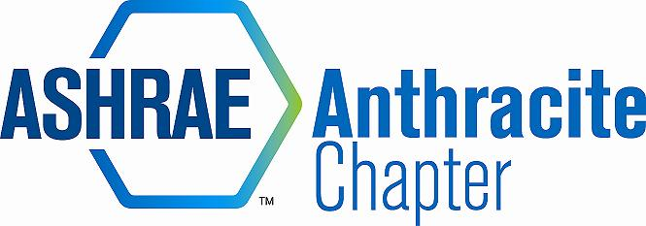
AGENDA – January Board Meeting
January 20, 2015
Patte’s, Wilkes Barre, PA
- Call to Order – call to order MA (5:09)
  - Roll Call
  - Motion to approval of November 2014 Meeting Minutes, by RK, 2nd DM
- 2013-14 OFFICERS & CHAIRS
 | Present | Absent
Matt Archey, PE(MA)…….President | X
Rich Karns(RK)………...President-Elect | X
Patrick Salmon(PS)……Vice-President | X
Alyssa Procida(AP)….. Treasurer | X
Jon Keller(JK)…………….Secretary & Membership Promotion | X
Tracey Jumper(TJ)…….Board of Governors & Student Activities | X(late)
Dan Mello (DM)………..Board of Governors | X
John Durdan,PE(JD)...Board of Governors |  | X
Dave Onufer (DO)..…..Chapter Technology Transfer Chair |  | X
Maxwell Tamasy (MT).Research Promotion | X
Will Seiberling(WS)….…Young Engineers in ASHRAE (YEA) | X
Walt Janus(WJ)………....Historian & Newsletter Editor | X
Karl Grasso(KG)………….Website Homepage Editor | X
Gary Debes(GD)………….Research Promotion Co-Chair |  | X
A.J. Speicher,PE(AJ)……..Grassroots Government Activities Chair |  | X

- Committee Reports (email updates going forward) (5:03-5:25)
  - Membership
    - Delinquent/prospective members
    - Matt Grasso new member
  - CTTC
    - D.O. has stepped down from the position. PS to be filling in for the balance of meeting slots.
    - PSPE and ASHE at Colorusso in Feb, for our DL (Michael Swan)
    - Remaining Programs (use cash positive venues)
    - MA suggests reaching out to RVC and invite to meeting
  - Treasurer
    - Chapter is using Square CC reader for events. – AP has CC reader on order.
    - Chapter to charge an additional $1.00 as a processing fee for CC reader.
    - Chapter Balance: $43,961.28
    - Memberships for December, $200 to deposit
  - Research Promotion
    - GD is no long with us, MT will be running RP moving forward. AJ Lello is willing to help for running the car show.
    - Tentatively April/May for car show
    - MT would like to add something in the newsletter. To look back at “Ron’s Rant”
  - Student Activities – K-12 initiatives
    - TJ – has sent scholarship criteria via email for approval.
    - Scholarships to be announced 1st of April. Discussed who will be eligible.
    - WS suggests subsidized dues for activity with the chapter
    - Student chapter at Wilkes unable to charge dues, TJ working with professor to determine course of action.
    - TJ to email cub scout event
  - Nominating Committee
    - PS stepping down next term. We will have several positions to fill.
    - Required minimum of 5 people for nominating – MA, JK, MT will be on committee
    - VP, CTTC, and Treasurer positions needed to be filled
  - YEA
    - 5k walk/run/race – same – WS discussed with student chapter president (April)
    - Volunteers needed
    - To have detailed report for next month
    - YEA event w/ Wilkes – “Paint Night” – details to follow – (March)
  - GGAC
    - AS to commit more time to position
  - Historian – No report
- PAOE
  - MA reminds all to update PAOE totals every month
  - Send emails, CC appropriate people, Contact MA with any questions or issues.

- Old Business
  - Historical items for storage unit – PS has binder for

- New Business
  - Open Discussion – Golf tournament committee formation
  - RP opportunity from Denny McGraw – Save and Share Program residential electric generation affiliate program. Fixed at $0.086 kw/hr – Chapter to look into the details with society

- Review of Action Items (Secretary)
  - PAOE reminder
  - Finalize January & February programs
  - RP full circle before next month
- Adjournment Motion to adjourn DM , KG 2nd (6:02)

