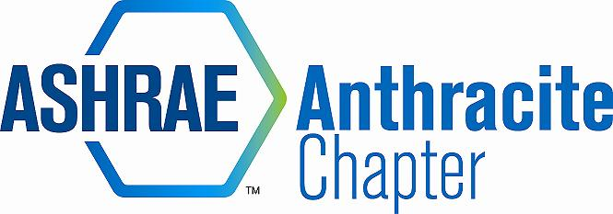
AGENDA – SUMMER PLANNING SESSION
July 15, 2014
COOPER’S SEAFOOD WATERFRONT, PITTSTON, PA
- Welcome and Introductions (5:15 pm)
  - Chapter Board and Committee Chairs
2013-14 OFFICERS & CHAIRS
 | Present | Absent
Matt Archey(MA)…….President | X
Rich Karns(RK)………...President-Elect | x
Patrick Salmon(PS)……Vice-President |  | x
Alyssa Procida(AP)….. Treasurer | X
Jon Keller(JK)…………….Secretary & Membership Promotion | X
Tracey Jumper(TJ)…….Board of Governors & Student Activities | x
Dan Mello(DM)………...Board of Governors | X
Tom Swartwood(TS)...Board of Governors |  | X
John Durdan(JD)……..…Board of Governors |  | x
Ron Sibulsky(RS)…………Research Promotion |  | x
Will Seiberling(WS)….…Young Engineers in ASHRAE (YEA) |  | x
Walt Janus(WJ)………....Historian & Newsletter Editor | x
Karl Grasso(KG)………….Website Homepage Editor | X
Gary Debes(GD)………….Former RVC of Membership Promotion | X
Phil Latinski…………………Chapter Member, Past President |  | x
Dave Onufer……………….CTTC | x
Max Tamasy……………….Co-chair of RP Committee | x
AJ Speicer…………………..GGAC | X

  - Regional Contacts (RVCs) – To be added to DropBox; chapter contacts & RVC contacts
- 2013-2014 Performance (5:15-5:30)
  - New Members
  - Research Promotion – Sept 12th- Centralized Training, Chicago – Max tentatively to attend
    - Great year for RP
  - PAOE – All areas made par with exception to GGAC
  - Open Discussion – Action item – update DropBox access
    - Dave Onufer wants a shirt
    - TJ – to get updated pricing for new shirts for CRC and Chapter
- 2014-2015 Year ahead (5:30-6:30)
  - CRC
    - Who is attending? Richmond, VA – August 2014
    - Chapter Reimbursement - $149/night hotel, $50 Registration, $30 Awards Luncheon, 100% travel – mileage to be determined
    - RP & MP chair to be reimbursed to CRC in VA for centralized training
  - Budget – Treasurer to schedule formal audit with audit committee
    - Student Chapter (meeting attendance, scholarships)
      - Did not do a scholarship last year, however, we need to budget for 2014-15 2 - $750 ($1,500 total)
      - Need to budget, Columbia Montour Vo-Tech Scholarship 2- $300 ($600 total)
    - New Banner
    - Attendance at CRC & workshops, centralized training, etc.
    - Other budget requests
  - PAOE
    - Get familiar with PAOE responsibilities for Chapter Chairs
    - Tom Phoenix to send PAOE newsletter to outline annual objectives
  - MBO Objectives
    - Leave the Chapter better than you found it
    - Growth of Student Chapter – TJ to implement Chapter U mentorship; have student board members sit through our board meetings
    - Mentorship of YEA
    - Contributions to our Communities
  - Committee Reports/Goals
    - CTTC – survey – Dave Onufer and Matt Archey to send a survey around for meeting topics
    - Historian
    - Membership Promotion – growth/retention
    - YEA – Activities
    - Student Activities; K-12 – order/rent a “Cool tools” kit – use with Wilkes Chapter
    - Treasurer – Audit; AP & WS to investigate credit card reader for 2015 season
    - Webmaster – Update website (Newsletters, minutes, photos, technical resources, etc.)
      - KG requests pictures from golf outing
    - GGAC*****
- Open Discussion (6:49)
    - GD – Programs from Lehigh Valley Chapter 2014-15, goal is getting for DL’s
    - Society will pay for DL transportation, Chapter to pay for additional expenses – GD suggests scheduling DL’s day after Lehigh Valley Chapter
    - Invitation to chapter - Lehigh Valley 50th Anniversary party August 14th, 2014 at Historic Hotel Bethlehem, 437 Main Street, Bethlehem PA 18018
- Adjournment: MA motion, 2Nd by AJ (7:00)

