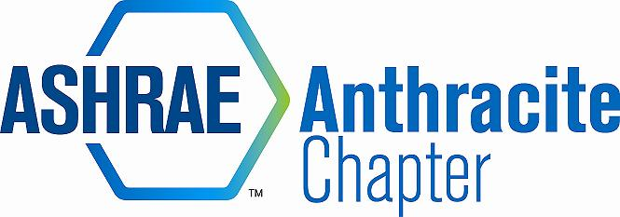
AGENDA – MARCH BOARD MEETING
MARCH 14, 2014
Arcaro & Genell, Old Forge, PA
- Call to Order RK (5:00PM)
  - Roll Call,
  - Approval of Previous Meeting Minutes –JD motion, DM 2nd
2013-14 OFFICERS & CHAIRS
 | Present | Absent
Matt Archey(MA)…….President |  | X
Rich Karns(RK)………...President-Elect | X
Patrick Salmon(PS)……Vice-President | X
Alyssa Procida(AP)….. Treasurer | X
Jon Keller(JK)…………….Secretary & Membership Promotion | X
Tracey Jumper(TJ)…….Board of Governors & Student Activities |  | X
Dan Mello(DM)………...Board of Governors | X
Tom Swartwood(TS)...Board of Governors |  | X
John Durdan(JD)……..…Chapter Technology Transfer Chair | X
Ron Sibulsky(RS)…………Research Promotion | X
Will Seiberling(WS)….…Young Engineers in ASHRAE (YEA) | X
Walt Janus(WJ)………....Historian & Newsletter Editor | X
Karl Grasso(KG)………….Website Homepage Editor | X
Gary Debes(GD)………….RVC of Membership Promotion | X
Phil Latinski…………………Chapter Member, Past President |  | X
Dave Onufer……………….Potential Member | X

- Nominating Committee Discussion (5:02-5:10)
  - Finalize nominees for open positions – DM is seeking board members, RK to president, PS stay as vice president, AP is in the “hot seat”, JK stationary, Need treasurer- RK will ask chapter tonight’s meeting, GB volunteered for general help, Dave O to become a member (potential candidate for board member)
  - The election is in April (nominations)
  - Ballot will be by Survey Monkey – Matt will create upon his return later this week
- Committee Reports (5:14-5:30)
  - CTTC
    - Remaining Programs
    - Positive feedback on many programs this year
  - Membership
    - Delinquent members – Upgrade member bios
  - Treasurer
    - Scholarships for CMAVTS (Columbia Montour Vo-Tech)
    - Bus trip to AHR Expo NYC; net $100, All payments have been collected
    - Dep
    - Scholarships for Wilkes -
    - In future, will need to balance scholarships with budget
    - Chapter balance: $45,797.12
  - Student Activities
    - K-12 volunteer opportunity –
  - Research Promotion – RS, GD $250 to car show, $250 O’Hora, GPI, WJ has Coleman Sales, Still need other RP check,
    - Current Sponsorship donations: $745.63
    - Adding a class: (6) Car Class, Added: Best work in progress, Longest Drive
    - Post Cards we made; send to last year’s attendees
    - Buzzkill – another car show in clarks summit on the same day.
    - Cones – were reserved; RK to see if Sordoni has any
    - RS needs assistance to get everything to the car show
    - RS has info on drop box
  - YEA
    - WS – Had student chapter activity trivia night, TJ & WS split cost of the tab.
    - WS – to set up a budget for YEA for next month meeting
  - Historian
    - WJ has historical display for tonight’s meeting
    - Got 8 boxes from Jerry Pisnowski for storage locker
  - GGAC -
- Old Business (5:36-5:38)
  - PAOE – Focus on your areas & Let Matt know if you need help!
      - Each committee has merits to obtain, go online & report
  - Storage Locker – still need items

- New Business (5:32-5:43)
  - Open Discussion – TJ talking to Wilkes about scholarships, waiting to hear back from Dr. Murphy, Have money ready for fall available, amount to be determined,
  - AP – is looking for scholarships CMAVTS $300 (HVAC) & $300 (drafting), Motion to donate $600 DM, 2nd by JD
  - Next month student month – table Wilkes scholarship discussion

- Adjournment Motion to adjourn RK, DM 2nd (5:45)

